Claude Certification — Building with the Claude API
Section 8 — Model Context Protocol
Contents
- Lesson 1 — Introducing MCP
- Lesson 2 — MCP Clients
- Lesson 3 — Project Setup
- Lesson 4 — Defining Tools with MCP
- Lesson 5 — The Server Inspector
- Lesson 6 — Implementing a Client
- Lesson 7 — Defining Resources
- Lesson 8 — Accessing Resources
- Lesson 9 — Defining Prompts
- Lesson 10 — Prompts in the Client
- Lesson 11 — MCP Review

Lesson 1 — Introducing MCP

Core idea
Model Context Protocol (MCP) is a communication layer that gives Claude context and tools without requiring a lot of tedious integration code. It shifts the burden of defining and executing tools away from your own server and onto specialized MCP servers.

Basic Architecture
An MCP Client (your server) connects to one or more MCP Servers, each of which bundles tools, prompts, and resources. Every MCP server acts as an interface to some outside service.
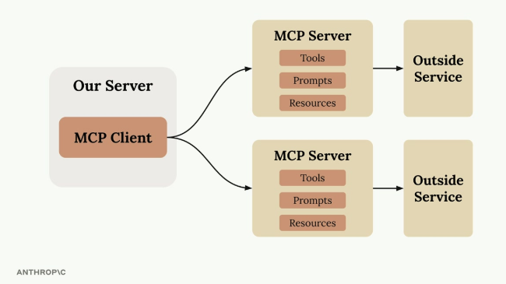
Our Server hosts an MCP Client that connects to multiple MCP Servers, each exposing Tools, Prompts, and Resources for an outside service.

Understanding MCP Through a Real Example
Consider a chat interface where users ask Claude about their GitHub data, e.g. "What open pull requests are there across all my repositories?" To answer this, Claude needs tools that can access GitHub's API. Without MCP, every one of those GitHub integration tools would have to be built by hand.
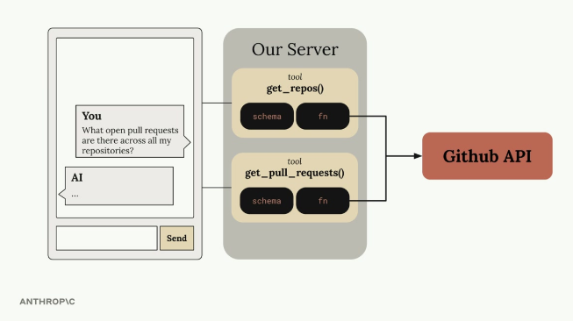
A user's GitHub question flows through tools like get_repos() and get_pull_requests(), each with its own schema and function, hitting the GitHub API.

The Tool Function Problem
GitHub's functionality is massive — repositories, pull requests, issues, projects, and much more. Building a complete GitHub chatbot would require authoring an incredible number of tools, each needing both a schema definition and a function implementation. That's a large amount of code a developer has to write, test, and maintain.
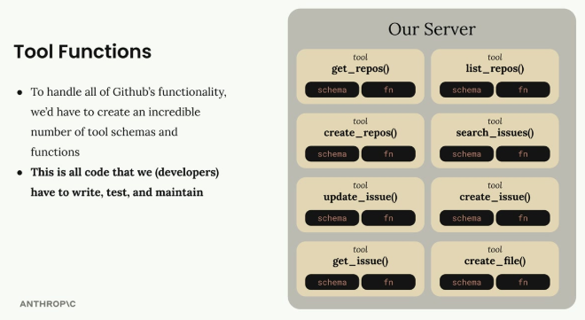
A wall of GitHub tools (get_repos, list_repos, create_repos, search_issues, update_issue, create_issue, get_issue, create_file) — all code the developer would have to write, test, and maintain.

How MCP Solves This
MCP shifts the burden of tool definitions and execution from your server to MCP servers. Instead of writing all those GitHub tools yourself, they are authored and executed inside a dedicated MCP server, which acts as a wrapper around GitHub's functionality — providing pre-built tools ready to use without implementing them yourself. MCP servers provide access to data or functionality implemented by outside services, packaging complex integrations into reusable components any application can connect to.
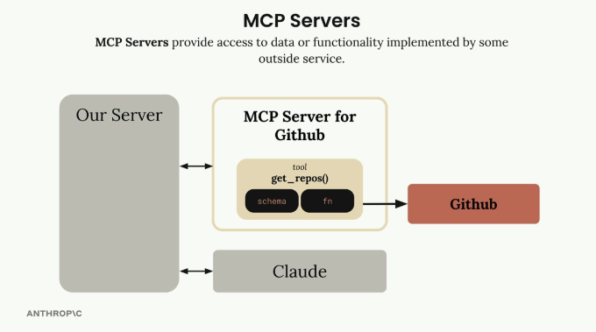
Our Server talks to a dedicated MCP Server for Github (which wraps a get_repos() tool talking to the Github API), and separately talks to Claude.

Who Authors MCP Servers?
Anyone can create an MCP server implementation. Often the service provider itself builds an official MCP implementation — for example, AWS might release an official MCP server with tools for its various services.

How Is MCP Different from Direct API Calls?
MCP servers provide tool schemas and functions that are already defined. Calling an API directly means being responsible for authoring those tool definitions yourself — MCP removes that implementation work.

Isn't MCP Just Tool Use?
A common misconception. MCP servers and tool use are complementary but different concepts: MCP is about who does the work of creating and maintaining the tools. With MCP, someone else has already written the tool functions and schemas — they're packaged inside the MCP server, ready to use with Claude's tool use.
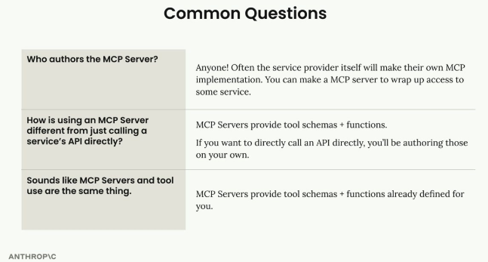
Anyone can author an MCP server; MCP saves you from writing tool definitions yourself; MCP servers provide the tool schemas + functions that tool use then relies on.

Practice Questions — Lesson 1
Choose the single best answer for each question (A–E).
1. What is Model Context Protocol (MCP) best described as?
A) A new model architecture that replaces Claude
B) A communication layer that gives Claude context and tools without requiring lots of tedious integration code
C) A pricing plan for API usage
D) A file format for storing prompts
E) A replacement for the Messages API
2. In the basic MCP architecture, what does the MCP Client connect to?
A) Directly to the outside service's database
B) One or more MCP Servers, each exposing tools, prompts, and resources
C) Only to Claude's training data
D) A single hardcoded tool function
E) The Anthropic Console
3. Without MCP, what would be required to build a complete GitHub chatbot?
A) Nothing — Claude already knows how to call GitHub's API natively
B) Authoring a large number of tool schemas and functions by hand, then testing and maintaining them
C) Only a single API key, no code required
D) A dedicated fine-tuned model for GitHub
E) Switching to a different LLM provider
4. According to the lesson, who can author an MCP server?
A) Only Anthropic
B) Only the end user of the application
C) Anyone — often the service provider itself builds an official implementation
D) Only certified MCP partners
E) Only open-source contributors, never companies
5. Why is "MCP is just tool use" considered a misconception?
A) Because MCP does not use tools at all
B) Because MCP is about who authors and maintains the tools — with MCP those schemas and functions are already written for you, inside the MCP server
C) Because tool use requires a different model than MCP
D) Because MCP servers cannot be used together with tool use
E) Because MCP replaces the need for a Messages API request entirely

Lesson 2 — MCP Clients

Core idea
The MCP client is the communication bridge between your server and MCP servers — the access point to all the tools an MCP server provides. It handles all the message passing and protocol details, so you don't have to.

Transport Agnostic Communication
MCP is transport agnostic: the client and server can talk over different communication methods. The most common setup runs both on the same machine, communicating over standard input/output (Standard IO). MCP clients and servers can also connect over HTTP, WebSockets, and other network protocols.
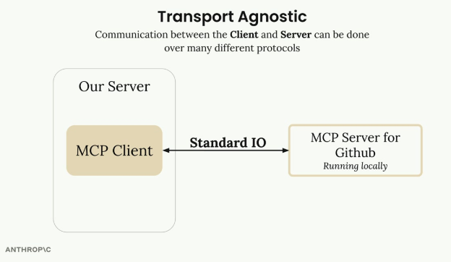
The MCP Client and a locally running MCP Server for Github communicating over Standard IO — one of several possible transports.
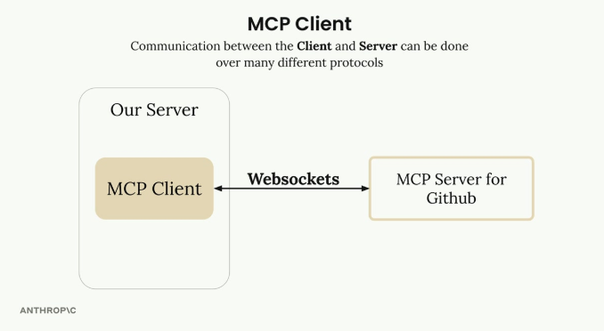
The same MCP Client and MCP Server for Github, this time communicating over Websockets — the transport can change without changing what the client and server exchange.

Message Types
Once connected, the client and server exchange specific message types defined in the MCP specification. The two main pairs are ListToolsRequest / ListToolsResult (the client asks "what tools do you provide?" and gets back the list) and CallToolRequest / CallToolResult (the client asks the server to run a specific tool with given arguments, then receives the result).
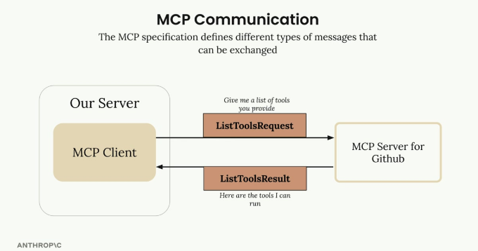
A ListToolsRequest ("give me a list of tools you provide") is answered with a ListToolsResult listing the tools the server can run.

Complete Flow Example
For the query "What repositories do I have?", the full flow runs through several components with clear responsibilities: the user submits the query to your server; your server asks the MCP client for the tool list, which sends a ListToolsRequest to the MCP server and gets back a ListToolsResult; your server now has the question and the available tools, so it makes the initial request to Claude; Claude examines the tools, decides it needs one, and responds with a tool use request; your server asks the MCP client to execute that tool, which sends a CallToolRequest to the MCP server, which in turn calls GitHub; GitHub's response flows back as a CallToolResult through the MCP server, to the MCP client, to your server; your server sends the tool result back to Claude in a follow-up message; and finally Claude formulates the complete answer, which your server passes back to the user.
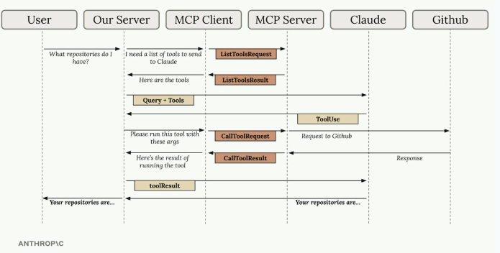
The complete round trip: User → Our Server → MCP Client → MCP Server → Claude → Github and back, covering ListToolsRequest/Result, ToolUse, CallToolRequest/Result, and the final toolResult passed back to Claude.
This flow has many steps, but each component has a clear responsibility — the MCP client abstracts away the complexity of server communication, letting the application focus on its own logic rather than protocol plumbing.

Practice Questions — Lesson 2
Choose the single best answer for each question (A–E).
1. What role does the MCP client play in the architecture?
A) It replaces Claude as the model that answers user questions
B) It's the communication bridge between your server and MCP servers, handling message passing and protocol details
C) It stores the user's conversation history permanently
D) It is only used to authenticate API keys
E) It runs entirely inside the MCP server
2. What does it mean for MCP to be "transport agnostic"?
A) MCP only works over Standard IO and nothing else
B) The client and server can communicate over different protocols, such as Standard IO, HTTP, or WebSockets
C) MCP servers cannot run on the same machine as the client
D) Transport agnostic means no data is ever transmitted
E) Every MCP server must use a different transport than every other server
3. What is exchanged in a ListToolsRequest / ListToolsResult pair?
A) The client asks the server what tools it provides, and the server returns the list
B) The client sends the arguments needed to run a specific tool
C) The server asks the client which model to use
D) The client uploads a file to the server
E) The server requests the user's original query
4. In the complete flow example, what triggers the CallToolRequest?
A) The user submitting their original query
B) Claude examining the available tools and deciding it needs to call one to answer the question
C) The MCP server starting up for the first time
D) The ListToolsResult being received
E) GitHub rejecting the initial request
5. According to the lesson, why does the flow involve so many steps even though it works well?
A) Because MCP is inefficient and should be avoided
B) Because each component (server, MCP client, MCP server, Claude) has a clear, separate responsibility, and the client abstracts away that complexity for the application
C) Because every message must be sent twice for reliability
D) Because Claude requires multiple separate API keys per step
E) Because GitHub requires a manual approval step for every tool call

Lesson 3 — Project Setup

Core idea
This lesson kicks off a hands-on project: a CLI-based chatbot built to understand how MCP clients and servers work together in practice, giving practical experience with both sides of the MCP architecture.

What We're Building
The chatbot lets users interact with a collection of documents through a command-line interface. It has two main components: an MCP client that handles user interactions, and a custom MCP server that manages document operations — including a tool to read a document and a tool to update one. All documents are stored in memory for simplicity, no database required.
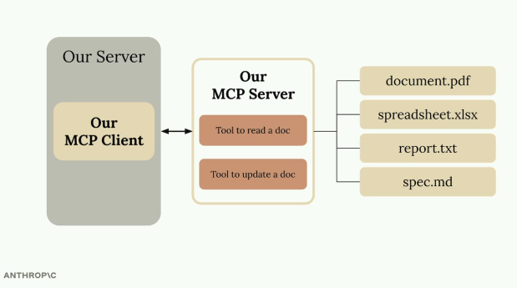
Our MCP Client talks to Our MCP Server, which exposes a tool to read and a tool to update documents, backed by an in-memory set of files (document.pdf, spreadsheet.xlsx, report.txt, spec.md).

Important Architecture Note
In real-world projects, a given project typically implements either an MCP client or an MCP server, not both — for example, an MCP server to expose your own service to other developers, or an MCP client to connect to existing MCP servers. This project builds both components purely for educational purposes, to see how they communicate and work together.
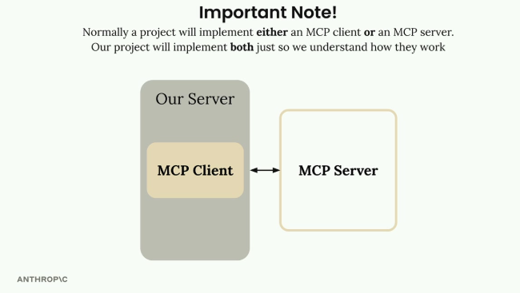
Normally a project implements either an MCP client or an MCP server; this project implements both, purely to understand how they work.

Project Setup
Download the cli_project.zip file attached to the lesson and extract it to a development directory, then open a code editor in the project folder. The project includes a README with setup instructions:
1. Add your Anthropic API key to the .env file.
2. Install dependencies using either UV (recommended) or pip.
3. Run the starter application to verify everything works.

Running the Application
From the project directory in the terminal, the main files include main.py, mcp_client.py, and mcp_server.py. To start the application:
# If using UV (recommended)
uv run main.py

# If using standard Python
python main.py
Once it starts successfully, a chat prompt appears. Testing it with a simple question like "what's 1+1?" should get a quick response from Claude — confirming the basic setup works before implementing MCP-specific features.

Practice Questions — Lesson 3
Choose the single best answer for each question (A–E).
1. What are the two main components of the CLI chatbot being built?
A) A database server and a caching layer
B) An MCP client that handles user interactions and a custom MCP server that manages document operations
C) Two separate Claude models running in parallel
D) A web frontend and a mobile app
E) An authentication server and a billing server
2. How are the documents stored in this project?
A) In a relational database
B) In memory, for simplicity — no database required
C) In a cloud storage bucket
D) Encrypted on disk with a separate key per file
E) They are not stored at all, only streamed
3. According to the lesson, what is typical in real-world MCP projects?
A) Every project must implement both an MCP client and an MCP server
B) A project typically implements either an MCP client or an MCP server, not both
C) MCP projects never need a server component
D) MCP clients cannot connect to servers built by other developers
E) Only Anthropic is allowed to build MCP clients
4. Why does this particular project implement both an MCP client and an MCP server?
A) Because that is required for any MCP application to function
B) Purely for educational purposes, to understand how they communicate and work together
C) Because the Anthropic API requires both to be present
D) Because documents cannot be read without both components
E) Because pip installation fails otherwise
5. What is the first thing that should happen after starting the application successfully?
A) The MCP server automatically shuts down
B) A chat prompt appears, and a simple question like "what's 1+1?" should get a quick response from Claude
C) The application immediately connects to GitHub
D) All documents in memory are deleted
E) The .env file is regenerated automatically

Lesson 4 — Defining Tools with MCP

Core idea
Building an MCP server is much simpler with the official Python SDK: instead of manually writing JSON schemas for tools, the SDK generates them from decorators and type hints. The example server manages in-memory documents and exposes two tools — one to read a document's contents, another to edit it via find-and-replace.

Setting Up the MCP Server
The Python MCP SDK lets you initialize a complete MCP server in a single line, using FastMCP:
from mcp.server.fastmcp import FastMCP

mcp = FastMCP("DocumentMCP", log_level="ERROR")
Documents are stored in a simple Python dictionary, where keys are document IDs and values are the document content:
docs = {
"deposition.md": "This deposition covers the testimony of Angela Smith, P.E.",
"report.pdf": "The report details the state of a 20m condenser tower.",
"financials.docx": "These financials outline the project's budget and expenditure",
"outlook.pdf": "This document presents the projected future performance of the",
"plan.md": "The plan outlines the steps for the project's implementation.",
"spec.txt": "These specifications define the technical requirements for the equipment"
}

Tool Definition with Decorators
The SDK turns tool creation from a verbose process into something clean and readable: instead of writing lengthy JSON schemas by hand, tools are defined with Python decorators and type hints.

Creating the Document Reader Tool
The first tool lets Claude read any document by its ID:
@mcp.tool(
name="read_doc_contents",
description="Read the contents of a document and return it as a string."
)
def read_document(
doc_id: str = Field(description="Id of the document to read")
):
if doc_id not in docs:
raise ValueError(f"Doc with id {doc_id} not found")

return docs[doc_id]
The @mcp.tool decorator automatically generates the JSON schema Claude needs. The Field class from Pydantic supplies the parameter descriptions that help Claude understand what each argument expects.

Building the Document Editor Tool
The second tool performs a simple find-and-replace operation on a document, taking the document ID, the text to find, and the replacement text:
@mcp.tool(
name="edit_document",
description="Edit a document by replacing a string in the documents content with a new string."
)
def edit_document(
doc_id: str = Field(description="Id of the document that will be edited"),
old_str: str = Field(description="The text to replace. Must match exactly, including whitespace."),
new_str: str = Field(description="The new text to insert in place of the old text.")
):
if doc_id not in docs:
raise ValueError(f"Doc with id {doc_id} not found")

docs[doc_id] = docs[doc_id].replace(old_str, new_str)
The implementation uses Python's built-in string replace() method for simplicity.

Error Handling
Both tools include basic error handling for the case where Claude requests a document that doesn't exist: an invalid document ID raises a ValueError with a descriptive message that Claude can understand and potentially act on.

Key Benefits of the SDK Approach
- Automatic JSON schema generation from Python type hints
- Clean, readable code that's easy to maintain
- Built-in parameter validation through Pydantic
- Reduced boilerplate compared to manual schema writing
- Type safety and IDE support for development
The MCP Python SDK turns what used to be a complex process of writing tool definitions into something that feels natural for Python developers — the business logic stays front and center while the SDK handles the protocol details.

Practice Questions — Lesson 4
Choose the single best answer for each question (A–E).
1. What does the @mcp.tool decorator do?
A) It deploys the server to production automatically
B) It automatically generates the JSON schema that Claude needs, from Python decorators and type hints
C) It encrypts the tool's input parameters
D) It converts the tool into a REST API endpoint
E) It restricts the tool to a single user session
2. How are documents stored in this MCP server example?
A) In a PostgreSQL database
B) In a simple Python dictionary, with document IDs as keys and content as values
C) In individual files on disk
D) In a Redis cache
E) In a cloud object store
3. What role does the Field class from Pydantic play in tool definitions?
A) It handles authentication for the MCP server
B) It supplies parameter descriptions that help Claude understand what each argument expects
C) It converts documents from Markdown to plain text
D) It manages the server's logging level
E) It defines the transport protocol used
4. How does the edit_document tool perform its find-and-replace operation?
A) With a custom regex engine built into the SDK
B) Using Python's built-in string replace() method
C) By calling an external text-processing API
D) By rewriting the entire document from a template
E) It cannot perform find-and-replace, only full overwrites
5. What happens when a tool is called with a document ID that doesn't exist in docs?
A) The server silently creates a new empty document with that ID
B) It raises a ValueError with a descriptive message that Claude can understand
C) The request is queued until the document is created
D) The MCP server crashes and must be restarted
E) It returns an empty string with no error

Lesson 5 — The Server Inspector

Core idea
When building MCP servers, you need a way to test functionality without connecting to a full application. The Python MCP SDK includes a built-in, browser-based inspector that lets you debug and test your server in real time.

Starting the Inspector
With the Python environment activated (check the project's README for the exact command), start the inspector with:
mcp dev mcp_server.py
This starts a development server on port 6277 and gives a local URL to open in the browser, loading the MCP Inspector dashboard. The inspector is actively being developed, so the interface may look different from any given screenshot — but the core functionality for testing tools, resources, and prompts should stay similar.
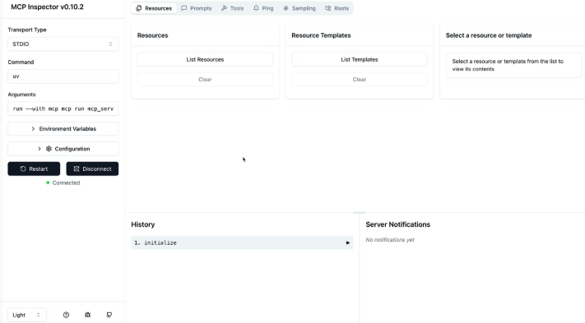
MCP Inspector connected via STDIO, showing the Resources, Prompts, Tools, Ping, Sampling and Roots tabs, plus request History and Server Notifications panels.

Connecting and Testing Tools
Clicking "Connect" on the left starts the MCP server. Once connected, a navigation bar shows sections for Resources, Prompts, Tools, and other features. To test a tool:
- Navigate to the Tools section
- Click "List Tools" to see all available tools
- Select a tool to open its testing interface
- Fill in the required parameters
- Click "Run Tool" to execute and see results

Testing Document Operations
To test a document reading tool, you'd enter a document ID (like "deposition.md") and run the tool — the inspector shows the result, including any returned content or success messages. Operations can be chained to verify functionality: after editing a document by replacing text, running the read tool again immediately confirms the change was applied correctly.

Development Workflow
The inspector creates an efficient development loop: make changes to the MCP server code, test individual tools through the inspector, verify results without needing a full application setup, and debug issues in isolation. This becomes essential as servers get more complex — it removes the need to wire the server up to Claude or another application just to test basic functionality, making development much faster and more focused.

Practice Questions — Lesson 5
Choose the single best answer for each question (A–E).
1. What command starts the MCP Inspector for a server file named mcp_server.py?
A) mcp run mcp_server.py
B) mcp dev mcp_server.py
C) python inspector.py mcp_server.py
D) mcp inspect --file mcp_server.py
E) uv inspector mcp_server.py
2. What port does the inspector's development server start on?
A) 3000
B) 8000
C) 6277
D) 5173
E) It is chosen randomly each run
3. What is the main purpose of the MCP Inspector, according to the lesson?
A) To deploy the MCP server to production
B) To let you debug and test your server in real time, without connecting it to a full application
C) To automatically write tool schemas from natural language
D) To manage authentication between MCP client and server
E) To convert an MCP server into a REST API
4. In the inspector, what is the correct sequence to test a specific tool?
A) Click Connect, then immediately click Run Tool with no other steps
B) Navigate to Tools, click List Tools, select a tool, fill in parameters, click Run Tool
C) Navigate to Resources, select the tool, then click List Templates
D) Restart the server, then select a tool from the History panel
E) Fill in parameters first, then click Connect
5. Why does the inspector make development faster, according to the lesson?
A) It removes the need to wire the server up to Claude or another application just to test basic functionality
B) It automatically fixes bugs in the tool code
C) It caches all tool results permanently so tests never need to rerun
D) It replaces the need for a Python environment entirely
E) It compiles the server into a faster binary

Lesson 6 — Implementing a Client

Core idea
With the MCP server working, it's time to build the client side: the piece that lets the application communicate with the MCP server and access its functionality. As with the server, in most real-world projects you'd implement either an MCP client or an MCP server, not both — this project builds both just to see how they work together.

Understanding the Client Architecture
The MCP client consists of two main components: the MCP Client, a custom class created to make using the session easier, and the Client Session, the actual connection to the server (part of the MCP Python SDK). The client session requires proper resource cleanup once it's no longer needed — that's why it's wrapped in the custom MCP Client class, to handle that cleanup automatically.
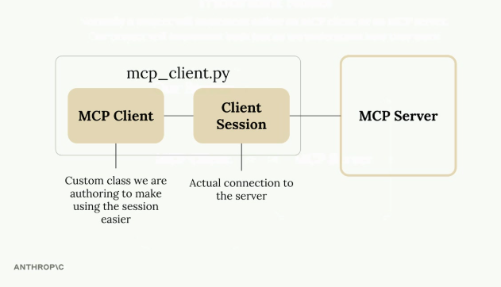
mcp_client.py wraps a Client Session (the actual connection to the MCP Server) inside a custom MCP Client class that makes using the session easier.

How the Client Fits Into the Application
The CLI code needs to do two main things with the MCP server: get a list of available tools to send to Claude, and execute tools when Claude requests them. The MCP client provides both capabilities through simple method calls the application code can use.

List Tools Method
This method gets all available tools from the server:
async def list_tools(self) -> list[types.Tool]:
result = await self.session().list_tools()
return result.tools
It accesses the session (the connection to the server), calls the SDK's built-in list_tools() function, and returns the tools from the result.

Call Tool Method
This method executes a specific tool on the server, passing the tool name and input parameters (provided by Claude) and returning the result:
async def call_tool(
self, tool_name: str, tool_input: dict
) -> types.CallToolResult | None:
return await self.session().call_tool(tool_name, tool_input)

Testing the Client
The client can be run directly for testing, using a testing harness that connects to the MCP server and calls the methods above:
async with MCPClient(
command="uv", args=["run", "mcp_server.py"]
) as client:
result = await client.list_tools()
print(result)
Running this test prints the tool definitions, including the read_doc_contents and edit_document tools created earlier in the MCP server.

Putting It All Together
With the client able to list and call tools, the complete flow can be tested end to end when the main application asks Claude about a document:
1. The code uses the client to get available tools.
2. These tools are sent to Claude along with the user's question.
3. Claude decides to use the read_doc_contents tool.
4. The code uses the client to execute that tool.
5. The result is sent back to Claude, who then responds to the user.
For example, asking "What is the contents of the report.pdf document?" triggers Claude to use the document reading tool, returning information about the 20m condenser tower document set up earlier in the server.
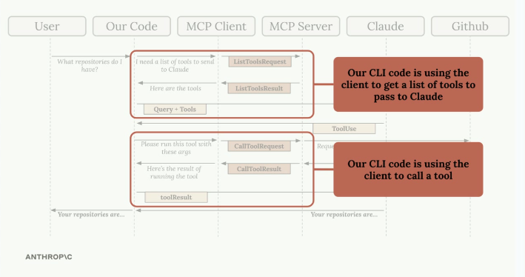
The same MCP request-flow diagram from Lesson 2, highlighting where the client code is used: once to get the list of tools to pass to Claude, and once to call a tool Claude has requested.
The client acts as the bridge between the application logic and the MCP server, making it easy to access server functionality without worrying about the underlying connection details.

Practice Questions — Lesson 6
Choose the single best answer for each question (A–E).
1. What are the two main components of the MCP client, as described in the lesson?
A) A logger and a cache
B) The MCP Client (a custom class) and the Client Session (the actual connection to the server)
C) A router and a load balancer
D) An authenticator and a rate limiter
E) A parser and a serializer
2. Why is the Client Session wrapped in a custom MCP Client class?
A) To add encryption to every message
B) To handle resource cleanup automatically, since the session requires proper cleanup when done
C) To rename the tools before sending them to Claude
D) Because Client Session cannot be imported directly
E) To convert the connection from STDIO to HTTP
3. What does the list_tools() method do internally?
A) It writes the tools to a local JSON file
B) It calls the session's built-in list_tools() function and returns the tools from the result
C) It asks Claude to generate a list of tools
D) It restarts the MCP server before listing tools
E) It queries the GitHub API directly
4. What parameters does call_tool() pass to the server?
A) Only the tool name
B) The tool name and the input parameters provided by Claude
C) The entire conversation history
D) The user's API key and the tool name
E) A list of all available tools
5. In the full example flow, what happens right after Claude decides to use the read_doc_contents tool?
A) The application restarts the MCP server
B) The code uses the client to execute that tool, then sends the result back to Claude
C) The user is asked to manually approve the tool call
D) The tool list is regenerated from scratch
E) The client session is closed immediately

Lesson 7 — Defining Resources

Core idea
Resources in MCP servers let you expose data to clients, similar to GET request handlers in a typical HTTP server. They're for scenarios where you need to fetch information rather than perform an action.

Understanding Resources Through an Example
Consider a document mention feature where users type @document_name to reference files. This requires two operations: getting a list of all available documents (for autocomplete), and fetching the contents of a specific document once mentioned. When a user types @, the available documents need to be shown; when they submit a message with a mention, that document's content is automatically injected into the prompt sent to Claude.
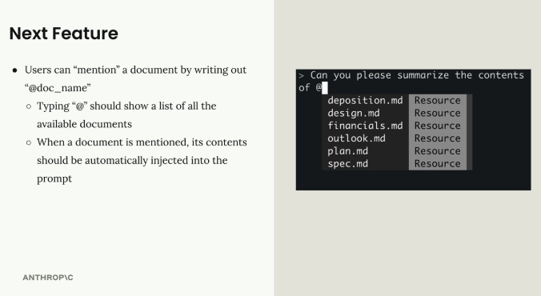
Typing "@" in the CLI chatbot should show a list of available documents (deposition.md, design.md, financials.md, outlook.md, plan.md, spec.md) as Resources; mentioning one should inject its contents into the prompt.
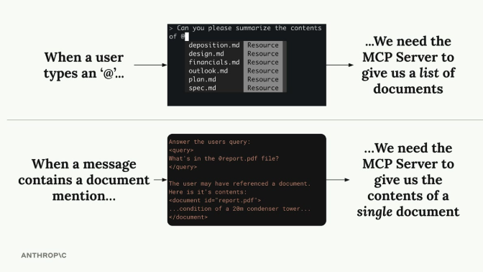
When a user types '@', the MCP Server needs to give a list of documents; when a message contains a document mention, the MCP Server needs to give the contents of that single document.

How Resources Work
Resources follow a request-response pattern: the client sends a ReadResourceRequest with a URI, and the MCP server responds with the data. The URI acts like an address for the resource being accessed.

Types of Resources
- Direct Resources — static URIs that don't change, like docs://documents
- Templated Resources — URIs with parameters, like docs://documents/{doc_id}
For templated resources, the Python SDK automatically parses the parameters from the URI and passes them as keyword arguments to the function.

Implementing Resources
Resources are defined with the @mcp.resource() decorator. A direct resource that lists documents:
@mcp.resource(
"docs://documents",
mime_type="application/json"
)
def list_docs() -> list[str]:
return list(docs.keys())
A templated resource that fetches a single document by ID:
@mcp.resource(
"docs://documents/{doc_id}",
mime_type="text/plain"
)
def fetch_doc(doc_id: str) -> str:
if doc_id not in docs:
raise ValueError(f"Doc with id {doc_id} not found")
return docs[doc_id]
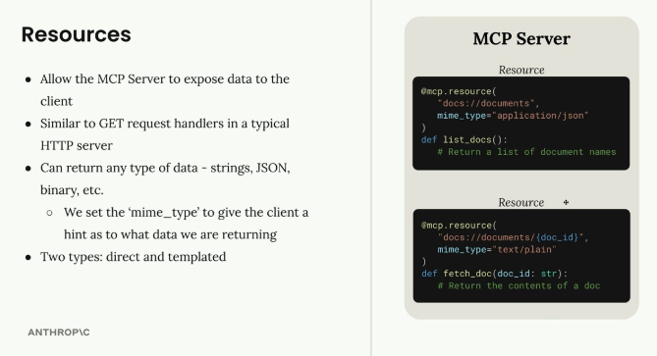
Resources allow the MCP Server to expose data to the client, similar to GET handlers; the list_docs resource returns document names, the fetch_doc resource returns a single document's contents.

MIME Types
Resources can return any type of data — strings, JSON, binary, and so on. The mime_type parameter gives clients a hint about what kind of data is being returned:
- application/json — structured JSON data
- text/plain — plain text content
- Any other valid MIME type for different data formats
The MCP Python SDK automatically serializes the return values — there's no need to manually convert them to JSON strings.
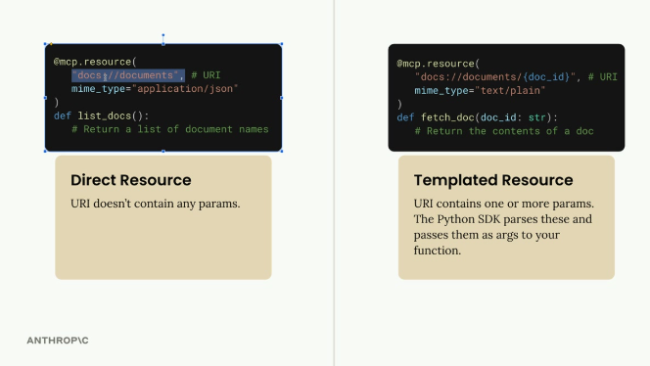
Direct Resource: the URI (docs://documents) doesn't contain any params. Templated Resource: the URI (docs://documents/{doc_id}) contains one or more params, which the Python SDK parses and passes as arguments to the function.

Testing Resources
Resources can be tested with the MCP Inspector, started the same way as before:
uv run mcp dev mcp_server.py
After connecting to the inspector in the browser, the Resources tab lists direct/static resources, and the Resource Templates tab shows templated resources that accept parameters. Clicking any resource tests it and shows the exact response structure the client will receive.

Key Points
- Resources expose data, tools perform actions
- Use direct resources for static data, templated resources for parameterized queries
- MIME types help clients understand response format
- The SDK handles serialization automatically
- Parameter names in templated URIs become function arguments
Resources provide a clean way to make data available to MCP clients, enabling features like document mentions, file browsing, or any scenario where information needs to be fetched from the server.

Practice Questions — Lesson 7
Choose the single best answer for each question (A–E).
1. What are resources in MCP servers most similar to?
A) POST request handlers that trigger actions
B) GET request handlers in a typical HTTP server — used to fetch information
C) WebSocket event listeners
D) Database migration scripts
E) Authentication middleware
2. What is the key difference between a direct resource and a templated resource?
A) Direct resources are faster to execute
B) A direct resource's URI doesn't contain params; a templated resource's URI contains one or more params
C) Templated resources can only return JSON
D) Direct resources require authentication, templated ones don't
E) There is no functional difference, only naming
3. In a templated resource like docs://documents/{doc_id}, how does doc_id reach the function?
A) It must be read manually from the request headers
B) The Python SDK automatically parses it from the URI and passes it as a keyword argument
C) It has to be hardcoded in the decorator
D) It is sent as a separate HTTP query string
E) It is ignored unless explicitly cast to an integer
4. What does the mime_type parameter in @mcp.resource() do?
A) It encrypts the resource's response
B) It gives the client a hint about what kind of data is being returned, like application/json or text/plain
C) It sets the server's listening port
D) It determines which transport (STDIO/HTTP) is used
E) It limits how many times the resource can be called
5. According to the lesson's Key Points, what is the core distinction between resources and tools?
A) Resources are synchronous, tools are always asynchronous
B) Resources expose data, tools perform actions
C) Resources can only be used with templated URIs
D) Tools require a mime_type, resources don't
E) Resources are tested in the Inspector, tools cannot be

Lesson 8 — Accessing Resources

Core idea
Resources let a server expose data that can be included directly in prompts, instead of requiring a tool call to access it — a more efficient way to provide context to Claude. With resources defined on the MCP server, the client needs a way to request and use them, acting as a bridge that handles communication and data parsing automatically.

Understanding Resource Requests
The flow is straightforward: when a user wants to reference a document (like typing "@report.pdf"), the application uses the MCP client to fetch that resource from the server and includes its contents directly in the prompt sent to Claude.
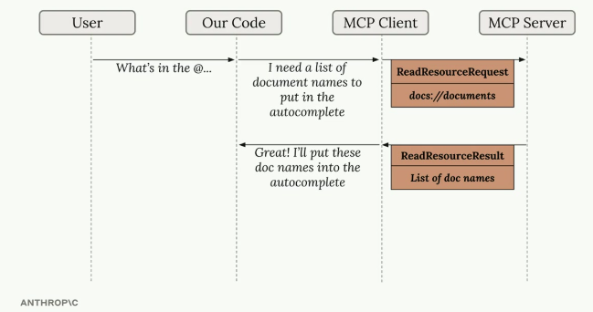
Our Code asks the MCP Client for a list of document names for the autocomplete; the MCP Client sends a ReadResourceRequest for docs://documents and gets back a ReadResourceResult with the list of doc names.

Implementing Resource Reading
The core functionality requires a read_resource function in the MCP client, taking a URI parameter that identifies which resource to fetch:
async def read_resource(self, uri: str) -> Any:
result = await self.session().read_resource(AnyUrl(uri))
resource = result.contents[0]
The response from the MCP server contains a contents list; typically only the first element is needed, which holds the actual resource data along with metadata like the MIME type.

Handling Different Content Types
Resources can return different types of content, so the client needs to parse them appropriately — the MIME type is the hint for the correct parsing strategy:
if isinstance(resource, types.TextResourceContents):
if resource.mimeType == "application/json":
return json.loads(resource.text)

return resource.text
This ensures JSON resources are parsed into Python objects, while plain text resources are returned as strings.

Required Imports
Making this work requires two imports in the MCP client: json to parse JSON responses, and AnyUrl (from pydantic) for proper type handling of the URI parameter.
import json
from pydantic import AnyUrl

Testing Resource Access
Once implemented, the functionality can be tested through the CLI application. Typing something like "What's in the @report.pdf document?" should show available resources in an autocomplete list, allow selecting one, fetch its content automatically, and include that content in the prompt to Claude — so Claude receives the document content directly in the prompt, without needing a tool call to access it, making the interaction faster and more efficient.
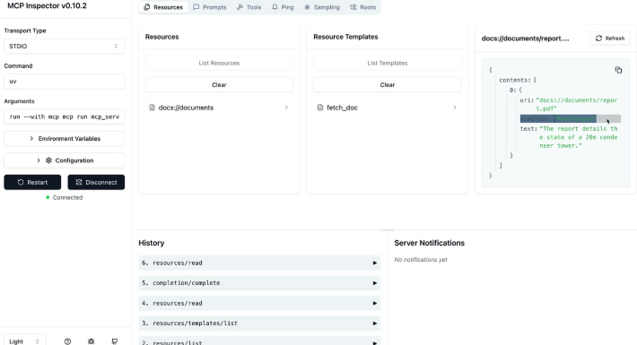
MCP Inspector showing the Resources and Resource Templates tabs (docs://documents, fetch_doc) and, on the right, the contents returned for docs://documents/report...: "The report details the state of a 20m condenser tower." History shows the sequence of calls, including resources/list, resources/templates/list and resources/read.

Integration with the Application
The MCP client code written here gets used by other parts of the application: read_resource becomes a building block other components can call to fetch document contents, list available resources, or integrate resource data into prompts. This separation of concerns keeps the code clean — the MCP client handles communication with the server, while the application logic focuses on how to use that data.

Practice Questions — Lesson 8
Choose the single best answer for each question (A–E).
1. What is the main advantage of using resources instead of tool calls to give Claude document content?
A) Resources are encrypted by default
B) Claude receives the document content directly in the prompt, without needing a tool call to access it
C) Resources automatically summarize the document before sending it
D) Resources bypass the need for an MCP server entirely
E) Resources can only be used with templated URIs
2. In the read_resource function, what does result.contents[0] represent?
A) The first document ever created on the server
B) The first element of the response, containing the actual resource data plus metadata like MIME type
C) The name of the MCP server
D) A list of all available tools
E) The HTTP status code of the request
3. How does the client decide how to parse a TextResourceContents object?
A) It always parses it as plain text, regardless of type
B) By checking resource.mimeType — application/json is parsed with json.loads, otherwise the raw text is returned
C) By guessing based on the file extension in the URI
D) It sends the content back to the server to be parsed
E) By checking the length of the returned string
4. Which import is needed to ensure proper type handling of the URI parameter in read_resource?
A) from pydantic import AnyUrl
B) import requests
C) from mcp import Url
D) import re
E) from typing import Union
5. According to the lesson, what keeps the MCP client code and the application logic cleanly separated?
A) The MCP client only runs in a separate process
B) The MCP client handles communication with the server, while the application logic focuses on how to use that data
C) They are written in different programming languages
D) The application logic never calls the MCP client directly
E) Resources cannot be accessed from application code

Lesson 9 — Defining Prompts

Core idea
Prompts in MCP servers let you define pre-built, high-quality instructions that clients can use instead of writing their own prompts from scratch — carefully crafted templates that give better results than what users might come up with on their own.

Why Use Prompts?
Consider wanting Claude to reformat a document into markdown. A user could just type "convert report.pdf to markdown" and it would work fine, but they'd likely get much better results with a thoroughly tested prompt that includes specific instructions about formatting, structure, and output requirements. Users can accomplish these tasks on their own, but they get more consistent, higher-quality results with prompts carefully developed and tested by the MCP server authors.
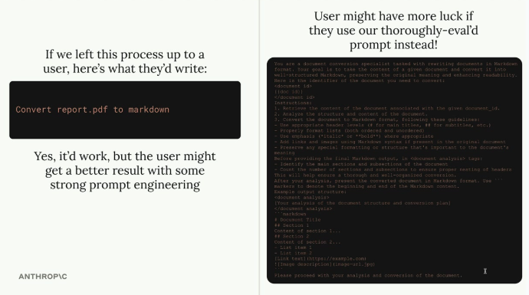
Left: if left up to a user, they might just write "Convert report.pdf to markdown" — it works, but a strong, well-engineered prompt on the right gives more consistent, higher-quality results.

How Prompts Work
Prompts define a set of user and assistant messages that clients can use directly; when a client requests a prompt, the server returns a list of messages that can be sent straight to Claude. The basic structure: define prompts with the @mcp.prompt() decorator, add a name and description for each, and return a list of messages that form the complete prompt — these prompts should be high quality, well-tested, and relevant to the MCP server's purpose.
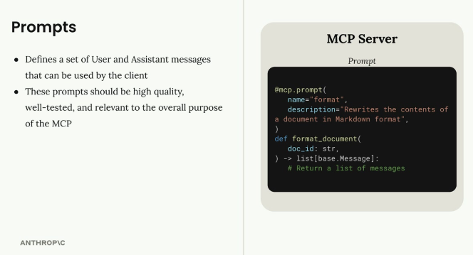
Prompts define a set of User and Assistant messages the client can use; the format prompt is registered with @mcp.prompt(name="format", description=...) and its function returns a list of base.Message objects.

Building a Format Command
Implementing a document formatting prompt starts with importing the base message types:
from mcp.server.fastmcp import base
Then the prompt function itself:
@mcp.prompt(
name="format",
description="Rewrites the contents of the document in Markdown format."
)
def format_document(
doc_id: str = Field(description="Id of the document to format")
) -> list[base.Message]:
prompt = f"""
Your goal is to reformat a document to be written with markdown syntax.

The id of the document you need to reformat is:

{doc_id}

Add in headers, bullet points, tables, etc as necessary. Feel free to add in extra formatting.
Use the 'edit_document' tool to edit the document. After the document has been reformatted...
"""

return [
base.UserMessage(prompt)
]

Testing Your Prompts
Prompts can be tested with the MCP Inspector: navigate to the Prompts section, select the prompt, and provide any required parameters. The inspector shows the generated messages that would be sent to Claude, making it possible to verify that the prompt interpolates variables correctly and produces the expected message structure before it's used in a real application.

Best Practices
- Focus on tasks that are central to the server's purpose
- Write detailed, specific instructions rather than vague requests
- Test prompts thoroughly with different inputs
- Include clear descriptions so users understand what each prompt does
- Consider how the prompt will work with the server's tools and resources
Prompts are meant to provide value that users couldn't easily get on their own — they should represent the MCP server author's expertise in the domain the server covers.

Practice Questions — Lesson 9
Choose the single best answer for each question (A–E).
1. Why would a client use an MCP server's pre-built prompt instead of writing its own?
A) Because writing prompts is not technically possible on the client side
B) Because a carefully crafted, tested prompt from the server author tends to give more consistent, higher-quality results
C) Because prompts are required by the MCP specification
D) Because pre-built prompts run faster than custom ones
E) Because Claude cannot process prompts written by end users
2. What does a prompt function decorated with @mcp.prompt() return?
A) A single string containing the raw prompt
B) A list of messages (list[base.Message]) that can be sent straight to Claude
C) A JSON schema describing the prompt's parameters
D) A boolean indicating whether the prompt succeeded
E) A file path to a saved prompt template
3. In the format_document example, what does base.UserMessage(prompt) represent?
A) A message from Claude confirming the format request
B) A user-role message containing the full formatting instructions to send to Claude
C) An internal log message for debugging
D) A system-level configuration message
E) An error message shown when doc_id is invalid
4. How can a prompt be tested before using it in a real application?
A) By deploying it directly to production and monitoring errors
B) Through the MCP Inspector's Prompts section, providing parameters and reviewing the generated messages
C) By manually inspecting the server's source code only
D) Prompts cannot be tested independently of the full application
E) By running a separate unit-testing framework unrelated to MCP
5. According to the Best Practices, what should prompts represent?
A) The bare minimum instructions needed to avoid errors
B) The MCP server author's expertise in the domain the server covers, providing value users couldn't easily get alone
C) A direct copy of the user's own wording
D) Generic instructions that apply equally to any possible server
E) A list of all available tools on the server

Lesson 10 — Prompts in the Client

Core idea
Prompts in MCP define a set of user and assistant messages that the client can use; they should be high quality, well-tested, and relevant to the overall purpose of the MCP server. This lesson covers the client-side methods needed to list and retrieve those prompts.

Implementing List Prompts
The list_prompts method retrieves all available prompts from the server, calling the session's list_prompts and returning the prompts array from the result:
async def list_prompts(self) -> list[types.Prompt]:
result = await self.session().list_prompts()
return result.prompts

Getting Individual Prompts
The get_prompt method retrieves a specific prompt with arguments interpolated into it. Requesting a prompt means providing arguments that get passed to the prompt function as keyword arguments; the method returns the messages from the result, forming a conversation that can be fed directly into Claude:
async def get_prompt(self, prompt_name, args: dict[str, str]):
result = await self.session().get_prompt(prompt_name, args)
return result.messages

How Prompt Arguments Work
A prompt function defined on the server can accept parameters — for example, a document formatting prompt might expect a doc_id parameter:
def format_document(doc_id: str):
# The doc_id gets interpolated into the prompt
When the client calls get_prompt, the arguments dictionary should contain the expected keys; the MCP server passes these as keyword arguments to the prompt function, allowing dynamic content to be inserted into the prompt template.

Testing Prompts in the CLI
Once implemented, prompts can be tested through the command-line interface: typing a forward slash surfaces available prompts as commands, selecting one may prompt for options like a document ID, and the complete prompt then gets sent to Claude.
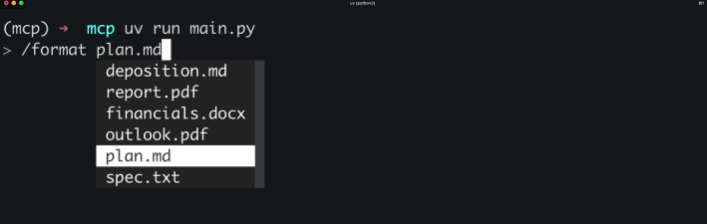
Typing "/format plan.md" in the CLI chatbot: the slash command shows an autocomplete list of documents (deposition.md, report.pdf, financials.docx, outlook.pdf, plan.md, spec.txt) to choose which one to format.
The workflow:
1. The user selects a prompt (like "format").
2. The system prompts for required arguments (like which document to format).
3. The prompt gets sent to Claude with the interpolated values.
4. Claude can then use tools to fetch additional data and complete the task.

Prompt Best Practices
- Make them relevant to the server's purpose
- Test them thoroughly before deployment
- Use clear, specific instructions
- Design them to work well with the available tools
- Consider what arguments users will need to provide
Prompts bridge the gap between predefined functionality and dynamic user needs, giving Claude structured starting points for complex tasks while keeping flexibility through parameterization.

Practice Questions — Lesson 10
Choose the single best answer for each question (A–E).
1. What does the list_prompts client method return?
A) A single default prompt
B) The prompts array from the session's list_prompts result
C) A list of every document on the server
D) A boolean indicating whether prompts are supported
E) The raw JSON schema of the MCP server
2. In get_prompt(prompt_name, args), what is args used for?
A) It configures the transport protocol
B) It's a dict of arguments passed to the prompt function as keyword arguments, to interpolate into the prompt
C) It lists the tools available to the prompt
D) It authenticates the client with the server
E) It sets the MIME type of the response
3. What does get_prompt() return that can be fed directly into Claude?
A) result.contents[0]
B) result.messages — a conversation formed from the prompt
C) result.tools
D) A single string with no structure
E) result.resources
4. In the CLI testing workflow, what happens right after the user selects a prompt like "format"?
A) The MCP server restarts
B) The system prompts for required arguments, like which document to format
C) The prompt is discarded and a new one must be selected
D) Claude immediately executes without any further input
E) The client disconnects from the server
5. According to the lesson, what do prompts bridge?
A) The gap between predefined functionality and dynamic user needs
B) The gap between the client and the transport layer
C) The gap between JSON and plain text MIME types
D) The gap between local and remote MCP servers
E) The gap between tools and the Python SDK

Lesson 11 — MCP Review

Core idea
This closing lesson ties the three MCP server primitives together: Tools, Resources, and Prompts. Each is controlled by a different party, is invoked differently, and serves a different purpose — understanding who decides when to use each is the key to designing an MCP server well.

The Three Primitives, Side by Side
- Tools — model-controlled: Claude decides when to call these, and Claude is the one that uses the results. Used for giving additional functionality to Claude.
- Resources — app-controlled: our app decides when to call these, and the results are used primarily by our app. Used for getting data into the app and adding context to messages.
- Prompts — user-controlled: the user decides when to use these. Used for workflows that run based on user input, like a slash command, a button click, or a menu option.
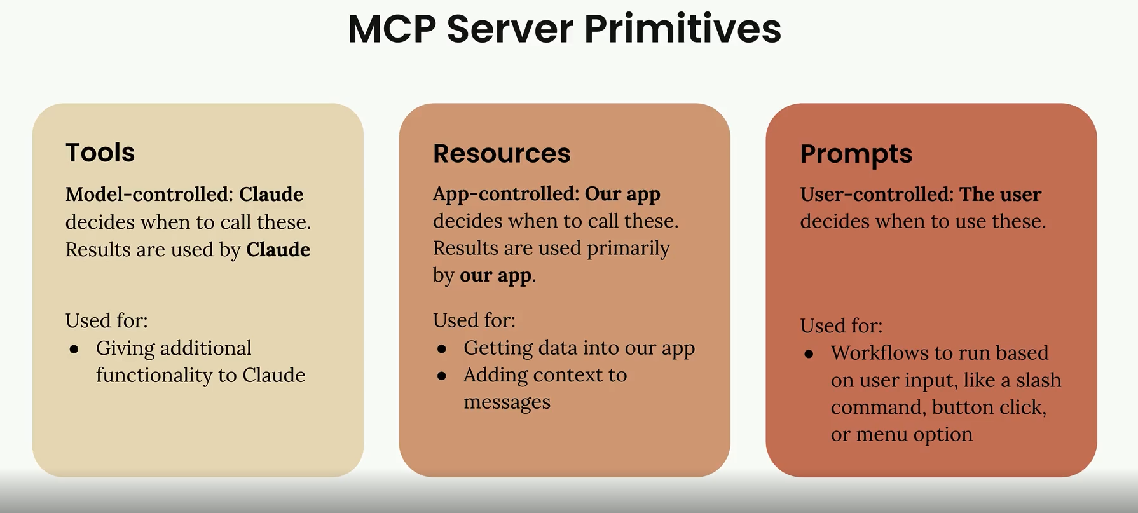
Side-by-side comparison of Tools (model-controlled, Claude decides and uses the results), Resources (app-controlled, our app decides and uses the results), and Prompts (user-controlled, the user decides when to use them).

Putting the Section Together
Across this section, the CLI document chatbot exercised all three primitives on both sides of the MCP connection: a server exposing read_doc_contents and edit_document as tools, list_docs and fetch_doc as direct and templated resources, and a format prompt built from base.UserMessage; and a client wrapping a Client Session to list and call tools, read resources by URI, and list and get prompts with interpolated arguments — all tested along the way with the MCP Inspector before being wired into the CLI application.

Practice Questions — Lesson 11
Choose the single best answer for each question (A–E).
1. Who decides when a Tool gets called, and who uses the result?
A) The user decides, and the app uses the result
B) Claude decides, and Claude uses the result
C) The app decides, and the app uses the result
D) The MCP server decides on its own, independent of Claude or the app
E) The result is discarded and never used
2. Resources are described as which kind of primitive?
A) Model-controlled
B) App-controlled
C) User-controlled
D) Server-controlled only, with no client involvement
E) Randomly controlled per request
3. Which primitive is triggered by things like a slash command, a button click, or a menu option?
A) Tools
B) Resources
C) Prompts
D) Templated resources only
E) None of the primitives are triggered this way
4. What are Resources primarily used for, according to the review?
A) Executing destructive actions on external systems
B) Getting data into the app and adding context to messages
C) Authenticating the MCP client with the server
D) Replacing the need for tools entirely
E) Formatting Claude's final response as markdown
5. What is the key distinction that separates Tools, Resources, and Prompts from each other?
A) The programming language used to implement each
B) Who controls when each one is used — the model, the app, or the user
C) Whether they run synchronously or asynchronously
D) Whether they are billed differently by Anthropic
E) Whether they require a network connection

